Lina M. Alvarez
Cedar Heights, Oregon | (503) 555-XXXX | lina.alvarez@enhancv.com | linkedin.com/in/username

OBJECTIVE
Highly motivated and academically driven undergraduate student seeking a merit-based scholarship to support continued studies in the field of education and social sciences. With a strong record of academic achievement, leadership involvement, and community service, I am committed to using my education to contribute positively to my community and pursue long-term academic and professional excellence.
EXPERIENCE
Volunteer Academic Tutor | September 2022 – Present
Community Learning Center, Portland
- Spearheaded weekly tutoring sessions for middle school students
- Collaborated with educators and volunteers to develop engaging learning materials
- Implemented structured study plans that improved student attendance and participation
Program Assistant (Part-Time) | June 2021 – August 2022
Oregon Youth Outreach, Portland
- Supported educational workshops focused on college readiness and study skills
- Collaborated with cross-functional teams to coordinate events and learning sessions
- Assisted in program planning and logistics, ensuring smooth execution of educational initiatives
Student Representative | September 2020 – May 2021
Student Government Association, Cedar Heights
- Represented student interests in academic planning discussions and school-wide initiatives.
- Collaborated with faculty and administrators to address student concerns
- Managed communication between student groups and administration
EDUCATION
Bachelor of Science in Education | Expected Graduation: May 2026
Oregon State University, Corvallis, OR
- Relevant Coursework: Educational Psychology, Curriculum Development, Sociology of Education, Research Methods
SKILLS
- Academic research and literature review
- Analytical writing and essay composition
- Public speaking and academic presentations
- Peer tutoring and instructional support
- Community engagement and outreach coordination
- Critical thinking and qualitative analysis

Thank You for Using Enhancv!
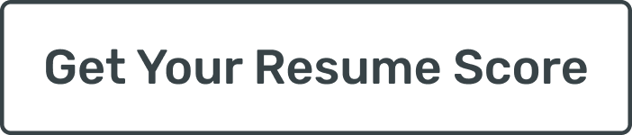
I wanted to personally thank you for choosing an Enhancv resume template while preparing your application.
Looking for a new role takes courage, focus, and persistence. You invested real effort into presenting your experience clearly and honestly, and that matters. A resume is more than a document. It reflects your choices, your priorities, and the work you stand behind.
If you would like to explore everything our platform offers, you can visit https://enhancv.com. There, you’ll have access to tools such as:
- Resume checks with real-time feedback
- ATS compatibility insights
- AI-powered content suggestions
- Cover letter creation and customization
- Role-specific guidance to improve clarity and impact
At Enhancv, we build tools for people who take their next step seriously. Seeing our templates and platform support job seekers like you is why we do this work.
Thank you for trusting us during an important moment in your career. I wish you confidence in your applications and success in the opportunities ahead.
Warm regards,
Volen Vulkov
Co-Founder


