Mason Thomas
Medical Assistant | Patient Care | EHR Proficiency | Care Coordination





(555) 987-6XXX mason.thomas.@enhancv.com Chicago, IL @s.levinsky

Certifications  Certified Medical Assistant (CMA) – National Healthcareer Association, 2020  Basic Life Support (BLS) – American Heart Association, 2021  Education  Associate of Applied Science (A.A.S.) in Medical Assisting  Purdue University  2018 - 2020  Clinical Rotations:  - Outpatient Clinic: Patient intake, vital signs, EHR documentation, patient education  - Primary Care Setting: Medication administration, exam room preparation, infection control  - Supported licensed providers in direct patient care under supervision  - Total supervised clinical hours available upon request  Skills  - Electronic Health Records (EHR) Systems  - Clinical Documentation & Charting  - Appointment Scheduling Software  - Medical Terminology  - Inventory & Supply Management  Key Achievements  - Improved Patient Flow Management: Redesigned clinic workflow, contributing to a 30% improvement in patient satisfaction scores.  - Medication Administration Accuracy: Maintained a 98% accuracy rate through strict adherence to medication protocols and documentation standards.  - Enhanced Patient Education: Developed patient education materials that improved understanding of treatment plans, receiving positive feedback from 85% of participants.  - Streamlined Appointment Coordination: Implemented scheduling improvements that reduced patient wait times by approximately 25% within six months. |  | Professional Summary  Certified Medical Assistant with 5+ years of experience in direct patient care, clinical procedures, and EHR documentation across outpatient healthcare settings. Proven ability to optimize patient flow, maintain high medication accuracy, and support quality, patient-centered care.  Work Experience  Senior Medical Assistant  Community Health Network | Indianapolis, IN  January 2022-Present  - Perform comprehensive patient intake, including medical histories, vital signs, medication reconciliation, and chief complaint documentation for 30–40 patients per shift.  - Prepare and maintain examination rooms in accordance with infection control and safety protocols, contributing to a 20% increase in patient visit efficiency.  - Administer medications and injections as prescribed, ensuring accurate documentation within the electronic health record and maintaining a 98% medication accuracy rate.  - Coordinate patient flow during peak clinic hours by organizing appointments, room assignments, and follow-ups, reducing wait times and improving patient satisfaction.  - Provide patient education regarding treatment plans, medications, and post-visit instructions, fostering trust and adherence to care plans.  - Collaborate closely with physicians, nurses, and administrative staff to support continuity of care and quality improvement initiatives.  Work Experience (cont.)  Medical Assistant  IU Health | Indianapolis, IN  June 2019-December 2021  - Assisted healthcare providers during clinical procedures, prioritizing patient comfort and proper preparation of instruments and supplies.  - Coordinated appointment scheduling, referrals, and follow-up communications, reducing missed appointments by 15% through proactive patient outreach.  - Maintained and organized patient records to ensure regulatory compliance and support successful internal audits.  - Provided patient education related to medications, procedures, and preventive care.  - Trained and supported newly hired staff on office workflows, EHR usage, and patient care standards.  Clinical Support Associate  St. Vincent Health | Indianapolis, IN  January 2018-May 2019  - Supported clinical staff by preparing examination rooms, stocking medical supplies, and ensuring operational readiness for daily patient care.  - Maintained strict compliance with HIPAA regulations and safeguarded patient confidentiality.  - Addressed patient and family concerns with professionalism and empathy, contributing to positive feedback regarding care experiences.  - Participated in team meetings focused on improving service quality and patient outcomes.  Languages  - English: Native  - Spanish: Advanced

Thank You for Using Enhancv!
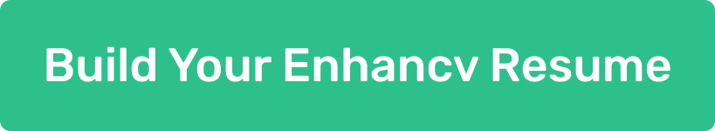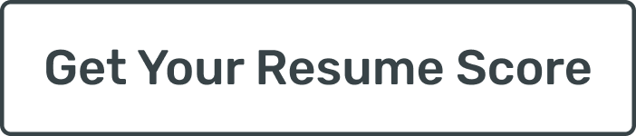
I wanted to personally thank you for choosing an Enhancv resume template while preparing your application.
Looking for a new role takes courage, focus, and persistence. You invested real effort into presenting your experience clearly and honestly, and that matters. A resume is more than a document. It reflects your choices, your priorities, and the work you stand behind.
If you would like to explore everything our platform offers, you can visit https://enhancv.com. There, you’ll have access to tools such as:
- Resume checks with real-time feedback
- ATS compatibility insights
- AI-powered content suggestions
- Cover letter creation and customization
- Role-specific guidance to improve clarity and impact
At Enhancv, we build tools for people who take their next step seriously. Seeing our templates and platform support job seekers like you is why we do this work.
Thank you for trusting us during an important moment in your career. I wish you confidence in your applications and success in the opportunities ahead.
Warm regards,
Volen Vulkov
Co-Founder


